SOLAR ECLIPSE REPRESENTED
IN THE PETROGLYPHS OF VIGRIMA (VENEZUELA)

Nelson Falcón^{1, 2} Omar León³
(1)Universidad de Carabobo. Facultad Exp. de Ciencias y Tecnología- Dpto. Física.
(2) Instituto de Astrofísica de Canarias 382000 La Laguna (Tenerife). nfalcon@ll.iac.es
(3) Universidad de Carabobo, Instituto de Investigaciones de la Facultad de Ciencias Económicas y Sociales.

Abstract

The Vigirima archaeological complex is characterised by the abundant presence of lithic sites whose age is unknown. The land registry of the petroglyphs, the revision of the techniques and styles used in its execution and the classification of the symbols in terms of the figurative characteristics has been done. Using archaeo-astronomic techniques some petroglyphs considered to contain astronomical content have been analysed and it was concluded that they corresponded to the total eclipse of the sun, which took place in AD 478. Following that, the construction of a cultural model showing the possible significance of the petroglyphs as archetypal expressions of the socio-cultural structure of the ethnic groups who created them, was proposed.
Key Words: Astronomy: History, petroglyphs, ancient ethnology.

I. Introduction
The outskirts of the neighbourhood of Vigirima (Tronconero Municipium, Guacara Edo. Carabobo) contain Venezuela's most important lithic sites. This archaeological complex takes up an area of approximately 12 hectares and is made up of the hillside of "Las Rosas" (call Zone C) and two natural promontories (calls mounds A and B). The place referred to as "Piedra Pintada" is located on the geographical coordinates 10° 18’ 04” Nort, 67° 53’ 14” West 474m over sea level (more precisely, the coordinates correspond to the summit of mound B in the sketch, see figure 1).
The Vigirima archaeological complex is characterised by the profusion and variety of its rock formations, expressed through megalithic alignments, rocky piles used in the delimitation of spaces and above all by the existence of 100 rocks with petroglyphs in bas-relief. Despite the many attempts to characterise the archaeology of the Cuenca del Lago de Valencia the age of the site has not been established and the interpretation of the stony registers is still far from complete; due principally to technical and methodological difficulties(Sujo, J.; 1975 and references therein) Nor does any consensus exist about which ethnic group their creators belonged to. The radiocarbon studies associated with ceramic objects of other sites pertaining to the Cuenca del Lago de Valencia estimate that the first inhabitants were at the dawn of the Christian era. This suggests that the site could be located in the NeoIndio Venezuelan period with ethnic groups belonging to the Arawaka linguistic families (Cruxent & Rouse 1961).
Recent studies of the Vigirima archaeological complex have allowed the establishment of stylistic resemblance between the carvings and the Barracoid style of pottery, corresponding to ethnic groups belonging to the Arawaka and Caribbean linguistic families and the subsequent occupation of the site by groups of humans archaeologically Valencoid between the 8th and 16th centuries AD (León, O. et al, 2000).
Despite the recent advances concerning the ancient ethnology of the Vigirima archaeological complex, important unknowns concerning the chronology and significance of the petroglyphs still remain. The objective of the current work is not to signal a free interpretation of the contents, nor to emphasise the representation of deities, rather it is to record some of the Vigirima petroglyphs by means of archaeo-astronomic techniques and suggest the contextual significance, which motivated their creators.

II Archaeological Context
All the petroglyphs were etched in bas-relief. The petroglyphs don't show remains of any pigmentation, so in order to increase the photographic contrast (see figures) the grooves on the substrata have been emphasised using a watery calcium hydroxide solution, which is both removable and innocuous. The profile of the grooves on the rock, which forms the substrata, shows a lithic work by erosion. The substrata are made up of metamorphic rocks with a hardness of between 3 and 4 on the Mohs scale. The grooves could have been made with hexagonal quartz crystal in which emerged in abundance in the region and whose hardness (7 degree Mohs scale) is greater than that of the substrata; particularly as the majority of the grooves have a depth of between 1 and 1.5 cm and a width of less than 2 cm, a typical range of the size of the quartz crystal prevalent in the region. Also, microscopic examination of the grooves shows the presence of quartz micro crystals encrusted in the substrata. In the most elaborate petroglyphs (see figure 3), the edge of the grooves shows a U-shaped hollow, suggesting either polishing or additional erosion. Some of these rocks show artificially cut edges, presumably made by the perforation of consecutive orifices, as shown by one rock of incomplete lithic work found in the mound B (Figure 2).
Demonstrating the technique of copying a carving on a sample of substrata of virgin rock using a quartz crystal found in the region, took some 30 minutes to etch a curved groove 15 cm in length and two additional connected points. The rocks of metamorphic schist that serve as the substrata are of variable thickness and weigh around 300 kg. They were also intentionally placed in a horizontal position or slanted to form cirques and artificial piles.
As regards design and form, the petroglyphs found have largely realistic and naturalistic content predominated by zoomorph representations (for examples see figures 4 and 5). What stand out in the figurative sense are the profound formal similarities between the Vigirima petroglyphs and the prehispanic styles of the Cuenca del Lago de Valencia belonging to the Barrancoide pottery series (Delgado et al, 1999). The morphological analysis of the carvings shows the tendency of their creators to reflect elements (both natural and cultural) of their surrounding environment. It is important to emphasise that in the majority of the petroglyphs the representations are of a naturalist-realist type with a predominance of zoomorph representations.
It is worth mentioning a group of symbols, etched in various rocks, characterised by the use of simple geometric figures such as dots, circles, semicircles and lines. One interpretation is their association with the sun, half moon and constellations, which could recall a possible and ancient eclipse of the sun. The rock carvings of astronomic character in figures 6, 7, 8 and 9 could represent a sun total eclipse.
A natural spectacle such as a total eclipse of the sun would cause, by its very unexpected and temporary nature, a need for communication and recording. A calculation of the astronomical position allows a contrast of the relative position of the planets and brightest stars (connected points of the rock carving) with the apparent position of the sun and the moon during the eclipse for the geographical longitude and latitude of the Vigirima archaeological complex.
At the site of the rock carving in figure 6; with a geographical location of 10º 18’ 10” N, 67º 53’ 17” W and 529 m over sea level; only 17 total eclipses of the sun between the years 100 BC and the 10th century AD were produced, as well as 100 partial eclipses of the sun (Oppolzer, T., 1962). The majority of the total eclipses took place very early in the morning or very late in the afternoon, which made observing them difficult due to the east and west horizons being invisible from this place because of the surrounding mountain range, and the expectation should be less likely that such eclipses occurred mid-morning, at midday or mid-afternoon. As well, the month of August is characteristically a period of drought in the region making the observation of the phenomenon more feasible. This allows one to establish that the connected points correspond to the total eclipse of the sun, which occurred in this region on Tuesday 31 August, 478, between 12:36 and 4:15; and which had a maximum duration of 3 minutes, 34 seconds. If one accepts that the figures correspond to a total eclipse of the sun visible in this place between the 1st and 14th centuries of our age, and by the harmony of the relative positions of the connected points relative to the stars of the first magnitude and of the planets in relation to the eclipsed sun, then they could only refer to that which happened in the year 478. One should highlight as well that the studies about the ancient ethnology of the basin of Valencia have found no evidence of permanent human settlements prior to the first century. The inhabitants of the Vigirima complex would have abandoned the settlement hundreds of years before, prior to the arrival of the Spanish conquerors in the basin of Valencia lake (Cruxent & Rouse, 1961).

III Conclusions
In general, the figurative features of this archaeological complex seem to indicate the importance of representing the surrounding natural world (fauna, natural phenomena, etc.). The high frequency of representations of nature at a figurative level, in comparison with the anthropomorphic representations, seem to indicate the priority of the natural world above that of the cultural world, and suggests a society with a close dependence of the individual on nature. In such an egalitarian tribal organisation, the shaman (chief-priest) would have had an important role as a mediator between man-nature and the woman as a symbol of the reproduction of the human force of work.
A systematic determination of the form of the Vigirima petroglyphs and the pottery styles La Cabrera and El Palito, provides information about two phenomenal expressions, distinct in the materials and techniques used, but in a united state of conscience, reflecting the same cultural view of the surrounding world.
To be exact, this formal relationship would permit registering the Vigirima archaeological complex between the years 1 and 700 of our era. The chronological coincidence is surprising being derived firstly from the stylistic analysis, and that obtained secondly by the use of astro-archaeological techniques. The latter would seem to be of greater specificity and certainty, being founded exclusively in physical evidence.

Acknowledgment:
We want to thank the hospitality and collaboration of the professor Dr. Rafael Rebolo (IAC) in the realization of the present work.

References.
Cruxent, J. M. & Rouse, I (1961) Arqueología cronológica de Venezuela. Unión Panamerica, Washington.
Delgado, Y.; León, O.; Falcón, N.; Bhaskaran, P. y Delgado, R.G. (2000). Análisis Estilístico de los Petroglifos del Complejo Arqueológico Vigirima. Boletín de la Sociedad Venezolana de Ciencias Naturales. N° 151 tomo XLVI, pp.109-117. Caracas.
Falcón, N.; León, O. y Delgado, Y.(2001) Vigirima: Complejo Arqueológico Rupestre de las Sociedades Tribales Prehispánicas de Venezuela. Revista Antropológicas. Instituto Nacional de Antropología e Historia. México D.F. (En Prensa).
Falcón, N.; León, O. y Delgado, Y.(2000) Acerca de los signos y significantes de los petroglifos de Vigirima. Mañongo, 15, 299-316, Valencia.
León, O.; Delgado, Y. & Falcón; N. (2000). Los petroglifos y Cosmogonía prehispánica en la Cuenca del Lago de Valencia.Revista FACES. Universidad de Carabobo, Año 9, # 8.
Oppolzer, T. (1962). Canon of Eclipses. Dover Publications, Inc. New York.
Sujo, J. (1975) El estudio del Arte Rupestre en Venezuela, Ediciones UCAB, Caracas.

Figures:
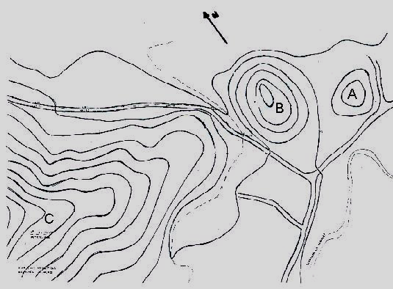
Figure1: sketch of the Vigirima archaeological complex (see text for details)
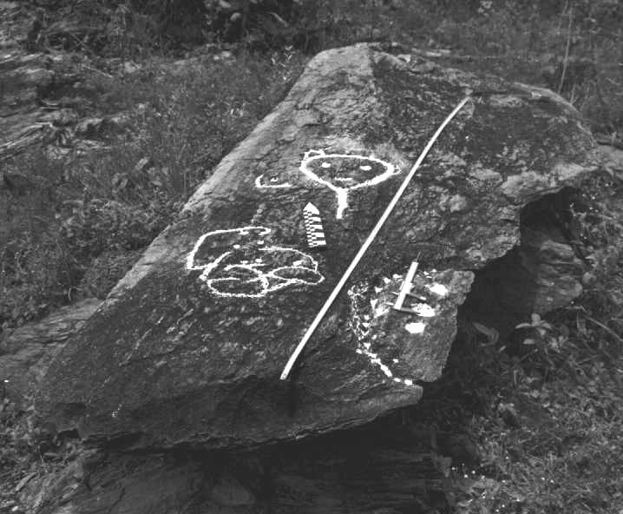
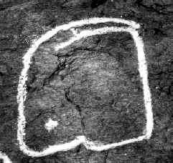
Figure 2: cutt and rock carvings example (Zona B). Figure 3: bas-relief plane (zona A)
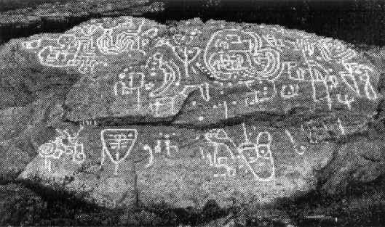
Figure 4: zoomorph representations (zona B) Figure 5: petroglyphs call “Piedra Pintada” (Zona B)
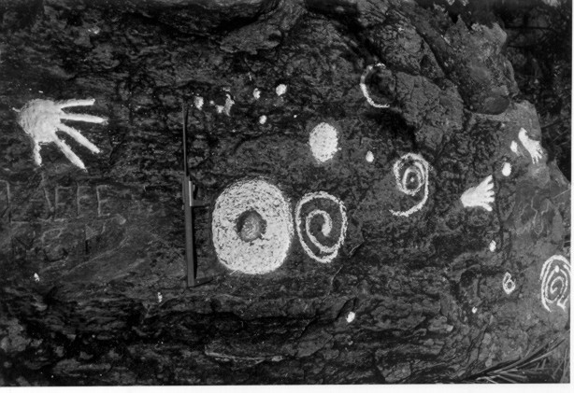
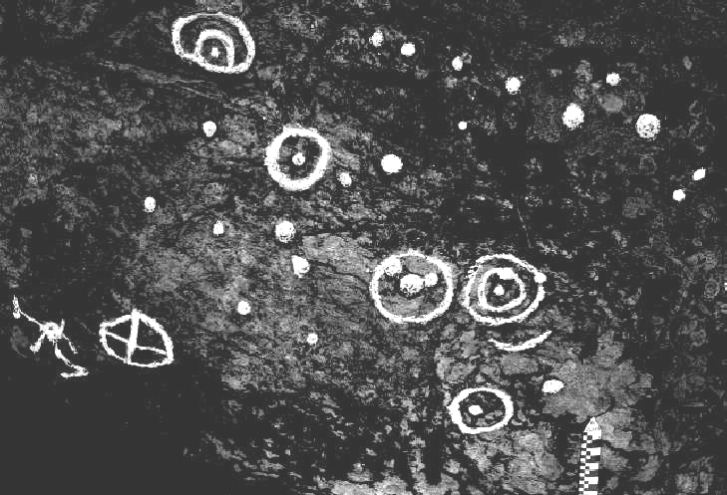
Figure 6: Eclipse Total of the Sun (zona C). The caliper is the 15 cm longitude in Nort direction. Notice the footprint, in symbolic traveling though the sky.

Figura 7: The Eclipse Total of the Sun (zona B). Notice the shaman in extreme left of the petroglyphs, in position of the ancient astronomy amateur observer .
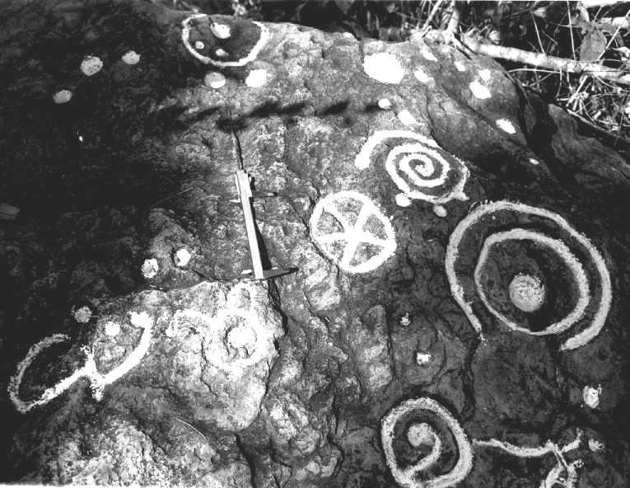

Figure 8 Astronomical Characters (zona C). Notice the bird nocturnal representation and the spiral emulative of the rotations.
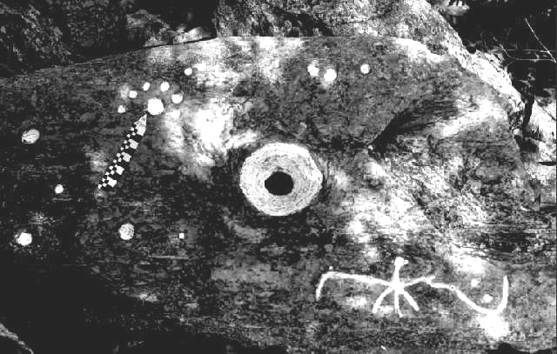

Figure 9: Eclipse (Zona B) Notice the hole central, traveling the rock of the 14 cm thickness, and the bird nocturnal.

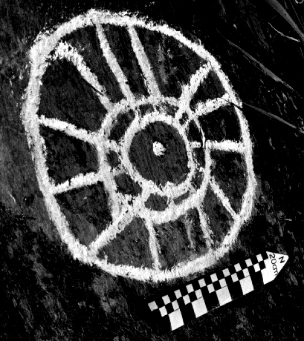

Figure 10: Abstract Representation (Zona B) ¿the sun corona during the total eclipse?.
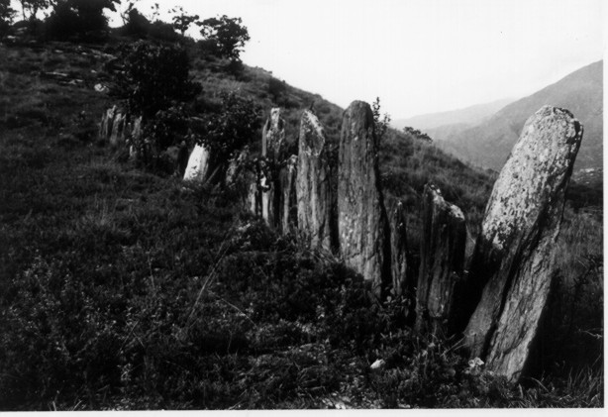

Figure 11: Menhires alignment (zona C). The Archaeoastronomy significance until can’t to be demostrated, but it is very posible .

